Portfolio Part 8
Download the zipped folder here:
my-ml-project.zip
ncluded Files
- fixed_program.py: Your corrected machine learning script
- test_fixed_program.py: Unit tests using unittest
- requirements.txt: All required Python packages
- README.md: Project overview
- .github/workflows/python-tests.yml: GitHub Actions CI workflow
Next Steps
- Unzip the folder.
- Create a GitHub repo, and push the contents:
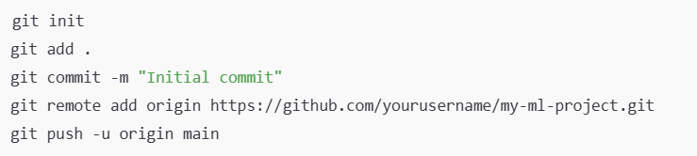
GitHub Actions will automatically run your tests after push! ✅
Provide screenshot that it is running (green tick) to be submitted as part of the portfolio.

